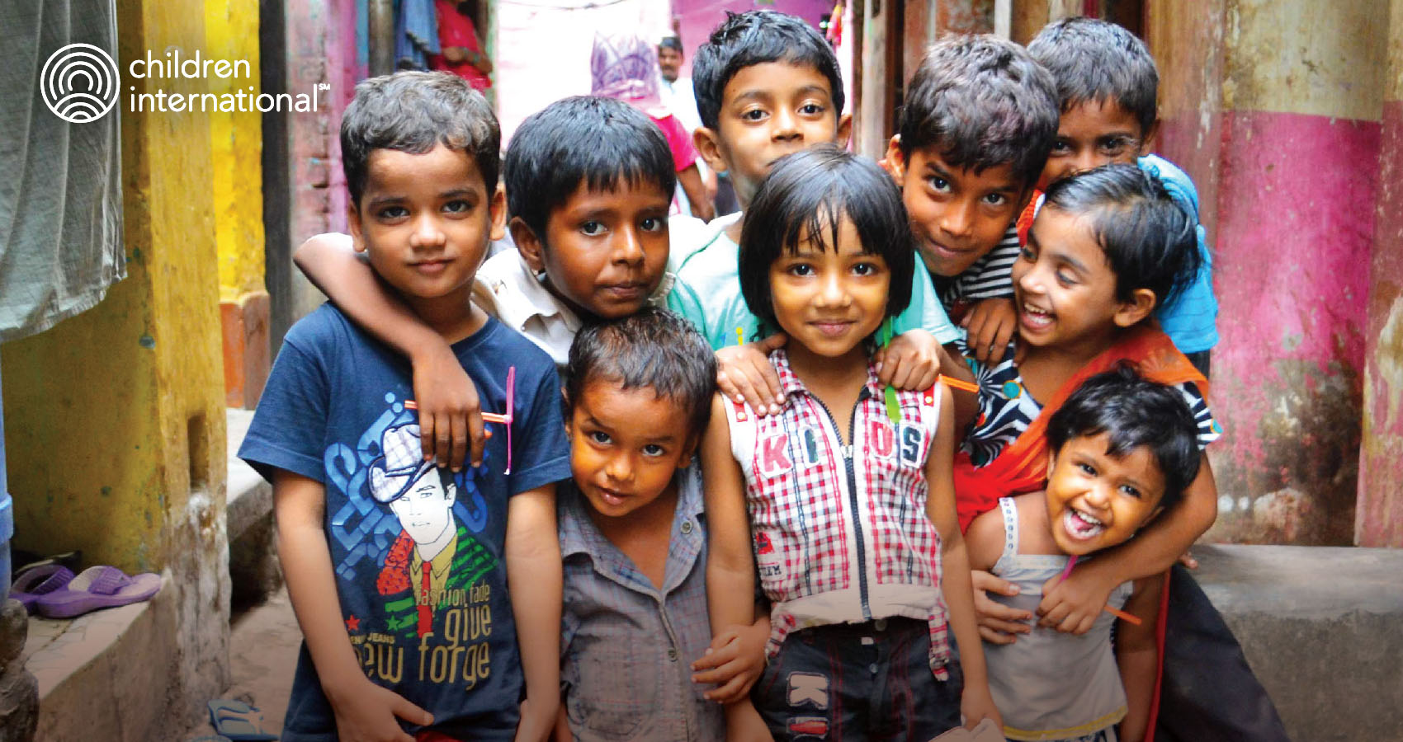
ABOUT CHILDREN INTERNATIONAL
ASSISTANT MANAGER - ACCOUNTING
SHARED SERVICE UNIT - PROJECT ONE CI
CHILDREN INTERNATIONAL INC. (CII)
Children International Inc., herein referred to as CII, based in Manila and CI-Philippines Inc., herein referred to as CIPI as based in Manila are both affiliates of Children International (CI), a global nonprofit, headquartered in Kansas City, USA,
Children International (CI) globally delivers child and youth development programming to break the cycle of generational poverty. Through a long-term, customized approach, we serve young people in 10 countries around the world for the first two decades of their lives.
By providing access to resources such as education, health care and positive role models, along with life skills and job skills they need to become sustainably employed adults, we are empowering our participants to improve their own lives, while transforming their families and communities. We are in it for the long haul, because we know that the nearly 220,000 children and youth we support around the world deserve a fighting chance.
As a locally registered organization, Children International Inc. (CII) delivers programs that support children and youth across its service areas. With more than 200 staff and over 1,500 volunteers, CII serves nearly 47,000 children and youth across communities in Manila, Quezon City, Caloocan, Malabon and Bulacan; the cities of Legazpi and Tabaco; and the municipalities of Daraga, Malilipot, Santo Domingo and Bacacay in Albay, Bicol Region. CII is also preparing to expand operations into future service areas. Meanwhile, CI-Philippines Inc. (CIPI) is a product-donation organization affiliated with Children International that connects donated health, education, mobility, hygiene and emergency-relief resources with underserved communities and institutions throughout the Philippines.

THE CAREER OPPORTUNITY (MORE ABOUT THE ROLE)
Children International Inc. is undertaking a significant organizational transition and integration initiative across multiple geographies to strengthen operational effectiveness, service delivery, and long-term impact for children and communities. The organization is implementing a 2 year “Project One CI: Integration, Growth & Sustainability” to support this transition, and the establishment of a shared services model. This role will provide dedicated accounting leadership and operational support during the implementation, integration, and stabilization of shared service operations across two legal entities: Children International Inc. and CI Philippines Inc. over this two-year period.
Reporting to the Senior Manager – Support Services, the Assistant Manager – Accounting is a newly created project role responsible for leading accounting, financial reporting, payroll oversight, compliance, audit preparation, and budget monitoring services for Children International Inc. and CI Philippines Inc. The role helps strengthen and standardize financial processes, controls, reporting practices, and service standards across both legal entities while ensuring continuity of operations throughout the transition project period.
Working closely with the Senior Manager – Support Services, the Assistant Manager – Accounting plays a key role in supporting the integration of systems, processes, and ways of working, while providing financial analysis, operational insights, and continuous improvement recommendations that support effective decision-making and the successful implementation of the organization's transformation objectives.
As a values-driven leader, the Assistant Manager – Accounting fosters a collaborative, accountable, and high-performing team culture aligned with CI's values. The role supports the engagement, development, and performance of direct reports, builds strong partnerships with stakeholders across both legal entities, and promotes service excellence, continuous improvement, and adherence to organizational policies, including child safeguarding requirements.
We are seeking a passionate advocate for children with strong accounting, financial reporting, audit, and compliance experience; sound knowledge of Philippine accounting and regulatory requirements; proven leadership and stakeholder management skills; and a commitment to delivering efficient, compliant, and mission-focused support services that enable lasting impact for children and communities.

RESPONSIBILITIES OF THIS ROLE
Planning and Organizational Support
- In coordination with the Senior Manager – Support Services, support the preparation, and monitoring of annual work plans and budgets for the Shared Services Unit (SSU) and the two legal entities it supports.
- Provide financial analysis and budget information to support planning, forecasting, and resource allocation decisions across both legal entities.
- Monitor budget performance and operational expenditures and provide recommendations to the Senior Manager – Support Services on opportunities to improve efficiency, cost effectiveness, and resource utilization across the organizations.

Internal Accounting Control
- Support the Senior Manager - Support Services in implementing and monitoring internal accounting controls, financial policies, and procedures across both legal entities to ensure consistency, compliance, and effective stewardship of organizational resources.
- Review financial transactions and accounting records to verify compliance with established controls, policies, donor requirements, and statutory obligations applicable to each legal entity.
- Identify control gaps or compliance risks affecting either organization and escalate findings and recommendations to the Senior Manager- Support Services.

Financial Management, Audit Support, Analysis and Reporting
- Oversee the day-to-day execution of accounting activities supporting the two legal entities, ensuring timely, accurate, and compliant financial processing and reporting.
- Oversee the monthly close and key financial accounts reconciliations.
- Analyze financial results, expenditure trends, cash flow positions, and budget variances for both organizations and provide recommendations to the Senior Manager – Support Services.
- Coordinate the preparation and review of financial reports, management reports, variance analyses, and statutory filings required by agency leadership, regional leadership, headquarters, donors, and regulatory authorities.
- Support the Senior Manager- Support Services in ensuring the consistent application of accounting processes, reporting standards, and financial controls across both legal entities.
- Coordinate payroll review, processing and related financial activities for both organizations, ensuring accuracy and compliance with organizational and statutory requirements.
- Coordinate audit preparations and provide required schedules, documentation, and supporting analyses for internal, external, donor, and statutory audits affecting legal entity.

Budget Management
- Support the Senior Manager – Support Services in coordinating the annual budgeting process for both legal entities, ensuring compliance with established guidelines and timelines.
- Prepare departmental budget, review and analyze budget submissions and forecasts to support informed decision-making and financial stewardship across both organizations.
- Prepare budget monitoring reports, variance analyses, and savings recommendations for review by leadership and the Senior Manager – Support Services.
- Coordinate with the different department heads for savings and consolidates idle fund savings and proposal for utilization to be submitted to the Senior Manager – Support Services for review and further action

Leadership & Development (LPI Aligned)
- Recruit, lead, and develop an effective and efficient shared services accounting team.
- Manage performance of direct reports through establishing clear accountability, coaching, and development.
- Champion a culture of accountability, ethics, service orientation, and continuous improvement.
- Lead change and support the direct reports to effectively adapt and integrate to the Child Path model, new operating model and as need in the future to other complex, ever-changing work environments.
- Enable a learning culture by ensuring constant learning and capacity building of team members throughout the implementation cycles, as well as partner with global teams and other stakeholders to share best practices and learnings.
- Demonstrate behaviors aligned to CI values consistently.
- Enable seamless information flow, break down silos, and stimulates effective collaboration across stakeholders within the global organization, agency, external collaborators as well as the community, maximizing collective impact for our children, youth, and families.

EDUCATION, EXPERIENCE AND KEY SKILLS
- Bachelor’s degree in accountancy from an accredited institution and Certified Public Accountant (CPA) designation required.
- 7–10 years of progressive accounting and finance experience covering financial reporting, budgeting, payroll, audit, compliance, internal controls, and management reporting, including at least 2 years of team leadership experience.
- Experience in supporting complex or multi-entity financial operations, including statutory reporting, audit coordination, regulatory compliance, and implementation of audit recommendations and process improvements.
- Proficiency in accounting systems and financial reporting tools, with experience in nonprofit, NGO, shared services, or multi-entity environments preferred, and a strong understanding of PFRS and Philippine regulatory requirements, including BIR, SEC, DSWD, and other applicable compliance frameworks.
- Excellent interpersonal and relationship building skills, proven experience in tactfully building and leveraging partnerships with external and other internal stakeholders (staff and volunteers) as well as demonstrating respectful treatment of others and comfortable working across cultures and diverse environments.
- Proven leadership and people skills including recruitment, coaching, performance improvement, and conflict management with the ability to inspire, influence, empower diverse teams and build a culture reflective of CI values and expectations of high performance.
- Strong analytical, communication, presentation, and report-writing skills, with the ability to synthesize complex information, identify trends and improvement opportunities, and clearly communicate insights and recommendations to support effective decision-making.
- Tech savvy with proficiency in Excel, familiarity with Dynamics 365 preferred, and/or other digital platforms to support accurate reporting, stakeholder engagement, and data-driven decision-making.
- Learning mentality characterized by listening, humility, and openness/courage to change.
- Fluency in English and at least one relevant local language with strong verbal and written communication and presentation skills.

OrGanizational Policies
- Strictly observe confidentiality and strong ethics regarding all beneficiary information/financial and other organizational data.
- Comply with and ensure adherence to the organization’s policies, safety and security protocols, child safeguarding norms and guidelines by self- and all stakeholders both internal and external.
- Promote diversity and inclusion, value other cultures, and demonstrate respect while relating with all organizational constituents irrespective of their race, color, faiths, gender, sexual orientation, age, caste, disabilities, experiences, beliefs, and ethnicity.

TRAVEL REQUIREMENT
This role is field based and the incumbent has to been comfortable and willing to travel often locally within Philippines to different field sites often (approx. 5-7 days a month). There may also be requirements to travel internationally from time to time.

Overall Decision Making & Supervision
- Complex decisions requiring independent actions and a high degree of initiative to resolve issues.
- This position is monitored on results.

JOB INFORMATION
- Job Title: Assistant Manager – Accounting (SSU)
- Department: Accounting
- CI Leadership Portrait: Leader of Others
- Reports to: Senior Manager – Support Services
- Other Primary Working Relationship:
  - Internal: Direct supervision of 2 Accounting Officer’s and 2 to 3 Accounting Assistants. Close coordination with Senior Manager - Operations Manager, Purchasing Manager, Program Managers, Program Technical Leads, SR Manager, Talent Growth, IT coordinator, Internal Auditor and relevant counterparts in other Agencies as well as Global Accounting
  - External: Auditors, Bankers, Tax Authorities, Regulatory Bodies.
- Grade: 8
- Engagement: 2-year project-based contract (1 January 2027 to 31 December 2028)

Application Process
Individual interested and believe they have the necessary skills and experience, please send an expression of Interest the Subject “Application for Assistant Manager – Accounting (Shared Service Unit)” to _____________________Cc copy _________________________
The deadline for receiving applications is _________. Candidates found suitable after the initial screening will be invited for a series of further interviews and interactions with different stakeholders within the organization. The successful candidates will be subjected to background verification and satisfactory references prior to their appointment
Children International and all its partners firmly support the principle and philosophy of equal opportunity for all individuals, regardless of caste, age, race, gender, sexual orientation, creed, disability or any other protected category pursuant to applicable national, state or local law. Children International Inc. (CII) is committed to safeguarding and promoting the welfare of children and young people and expects all staff, volunteers, and associates to share this commitment.

